**Assignment-2**

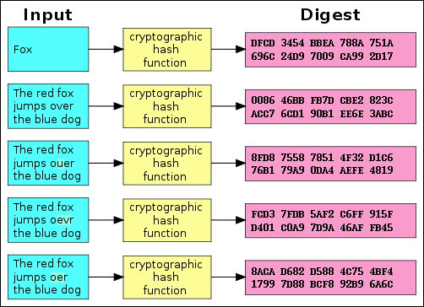

Hashes are the products of cryptographic [algorithms](https://www.howtogeek.com/howto/44052/htg-explains-what-are-computer-algorithms-and-how-do-they-work/) designed to produce a string of characters. Often these strings have a fixed length, regardless of the size of the input data. Take a look at the above Figure and you’ll see that both “Fox” and “The red fox jumps over the blue dog” yield the same length output.

Now compare the second example in the chart to the third, fourth, and fifth. You’ll see that, despite a very minor change in the input data, the resulting hashes are all very different from one another. Even if someone modifies a very small piece of the input data, the hash will change dramatically.

MD5, SHA-1, and SHA-256 are all different hash functions.

1. **Implement MD5, SHA-1 and SHA-256** cryptographic hash functions which will produce hash for different texts.
2. **Use Salt** for each of the hashing. (Study Salt before doing that).
3. **Investigate the computation time** required for these algorithms (using any functions of your preferred language) and find the order of these algorithms based on computational efficiency.